**OR LAB Assignment 3**

**Nikita 18AE30029**

Problem 1)

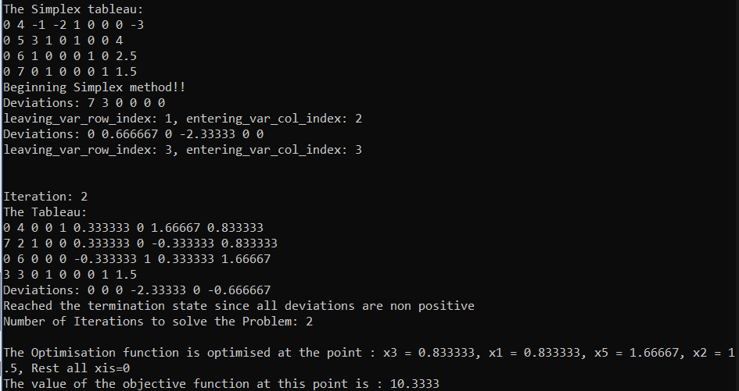

Problem 2)

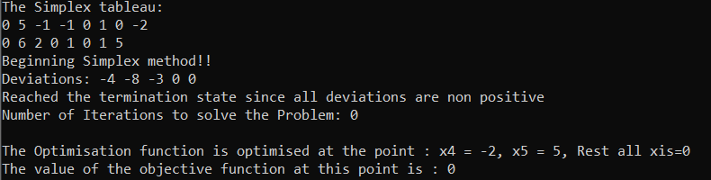

Problem 3)

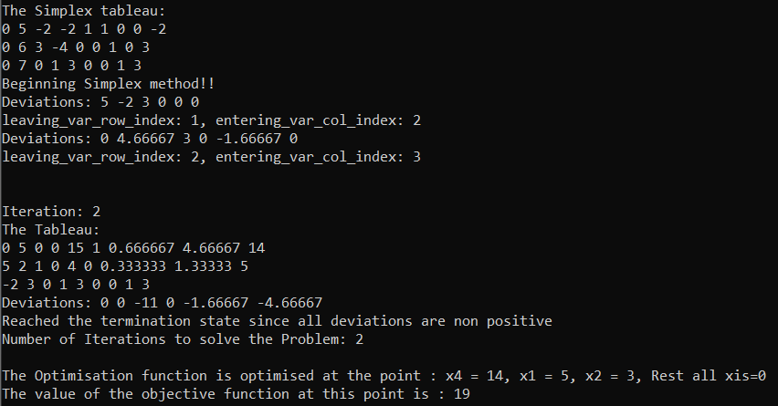

Problem 4)

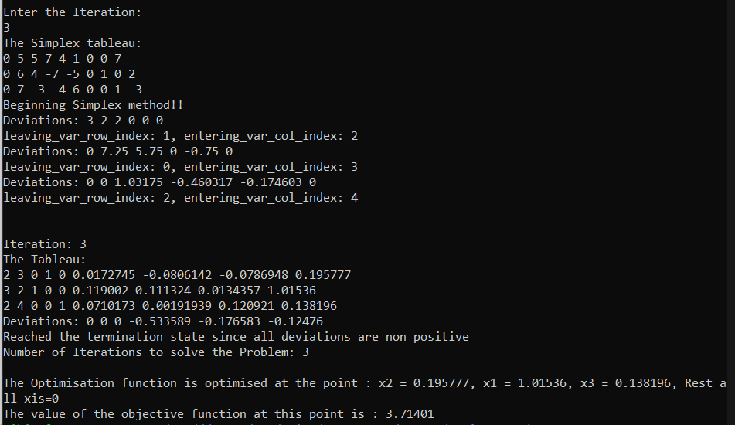

Problem 5)

